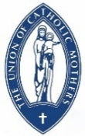
UCM NEWS No. 2- June 2025

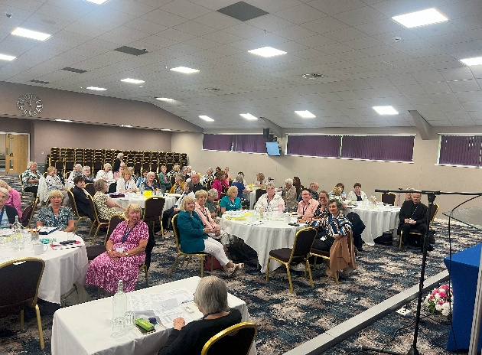
NATIONAL COUNCIL MAY 2025
Our National Council and AGM were well attended at The Hayes in Swanwick hosted by Liverpool.
Archbishop Malcolm McMahon attended on Tuesday for Mass, lunch and a talk during our afternoon session. We were especially grateful to the Archbishop giving us his time so close to his retirement.
We were pleased to welcome as guests UCM Wales President Rose Maunders and CWL President Siobhan Garibaldi to our Council.
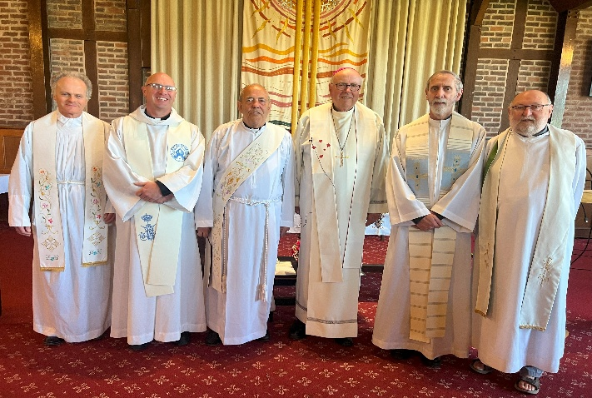
From right to left: Canon Lawrie Hulme, Bishop Alan Williams, Archbishop Malcolm McMahon, Deacon Peter Marshall, Fr Bill Surplus and Fr. David Potter

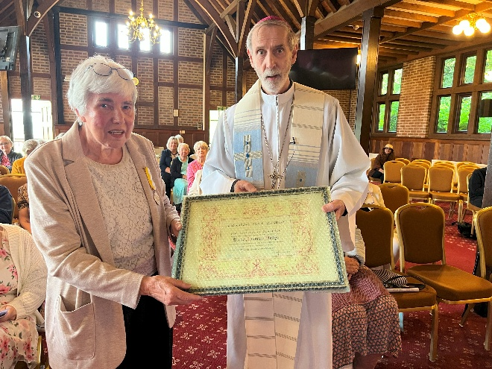

Our retiring President Joan Hodge receiving the Pro Ecclesia et Pontifice (for church and Pope) medal from Bishop Alan.
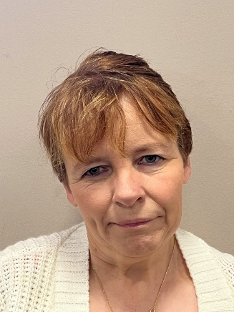

Our new President Mrs. Eileen Rodgers Priest was inducted at the final mass on Wednesday. Eileen is from the Birmingham Diocese and was formally their Diocesan President.
We welcome Eileen offering our prayers and support as she leads us over the next 3 years.
Is your Diocese working with local Youth?
Please inform Vivienne O’Byrne, National Welfare Officer if you have contacted your diocesan youth service and introduced UCM as a source of help and support; if so, what was the reaction? Have you been able to start any discussions on how the UCM may be able to help in running Youth in Action Scheme in the diocese? Are any parishes in your diocese running this scheme, if so, do they have a UCM foundation? How many members have expressed an interest in offering their help? Remember training is available. Further information available at https://faithinactionaward.co.uk/
CONGRATULATIONS
103rd Birthday Joan Jenkins past Liverpool Archdiocesan President
95th Birthday Josie Cribbin St Mary's Foundation Liverpool
Lilly Payne English Martyrs Foundation Birmingham
Foundation Anniversaries
A& B Hollington Foundation 65th Anniversary
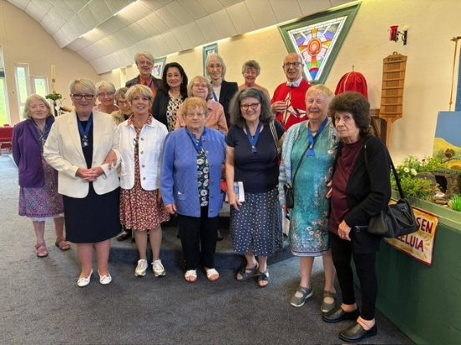
On Saturday 3rd May 2025 the members of Hollington UCM, St. Leonards-on-Sea celebrated their 65th year since their Foundation in 1960. The Holy Mass was said by the Parish Priest, Rev Fr. Miceal Beatty: The Word of the Lord was proclaimed by Mrs Eileen Harris MBE, Diocesan President and UCM prayers were led by Mrs Sylvia O’Rourke, Foundation President. Afterwards, all went to the Parish Hall for refreshments including a beautiful, iced cake made by a good friend to UCM, parishioner Mr Patrick Lee (retired master baker).
Text by Judy Harkins (Parish UCM sec) and Photos by Sue Mulligan
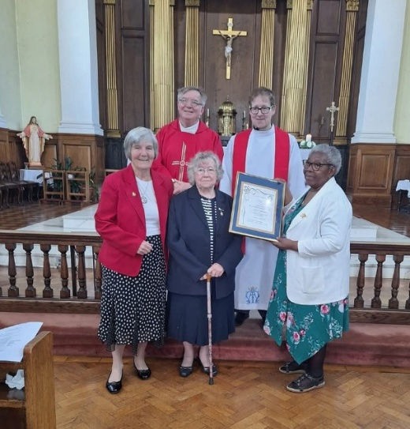
St Gregory’s Foundation 100th Anniversary Birmingham
At the celebration mass Angela Johnson also received her certificate for 50 years devoted service to the UCM. Bill and Pat Rogers celebrated 50 years of married life. Photo U C.M Spiritual Priest Fr Paul, Fr Conley PP, Angela Johnson (Sec.), Ellen Bates (President) and Vicky Adbedi (Treasurer).
Miriam Cunliffe Media Officer Birmingham Archdiocese
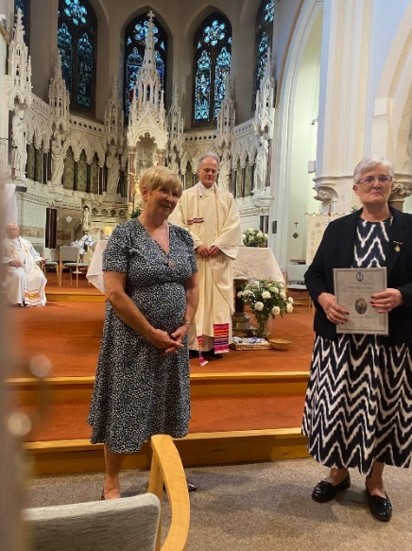
70th Anniversary Mass - St Edmund of Canterbury, Waterloo, Liverpool
The mass was concelebrated by Fr David, Monsignor Butchard former UCM chaplain and Fr John Cullen former parish priest of St Edmund of Canterbury, Waterloo. The service was held at St Thomas' Oratory, also called the, Irenaeus Centre, a drop-in centre as well as a Retreat centre and foodbank.
In the photograph are Liverpool Archdiocesan President, Mrs Kathy Buck, Liverpool Chaplain, Fr David Potter and Foundation President, Mrs Mandy Cassidy.

NEW FOUNDATIONS
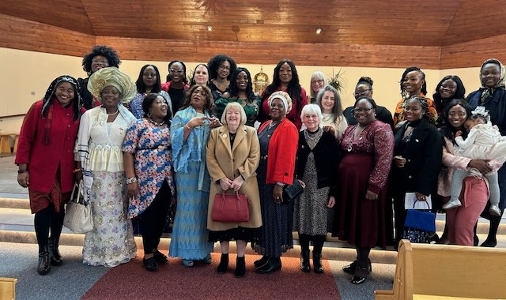
Ashford Kent Southwark
The enrolment of the new UCM Foundation, Ashford Kent with 26 members took place on Sunday 2nd March during the 10.30am mass at St Teresa of Avila. This wonderful event was followed by a celebration in the church hall. The new Foundation began meeting in early October, with officers being elected at the November meeting and committee roles being shared.
Several of the Diocesan Officers attended the enrolment including Sharon Bishop, the President. A few of the ladies from Ashford also attended the UCM Diocesan Pilgrimage at Aylesford on 24th May, giving them the opportunity to meet members from other Foundations. Margaret Whitham Kent Area Leader
Bostal Park Southwark
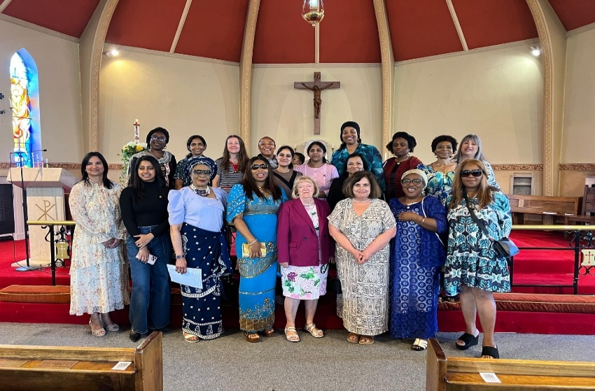
A lovely celebration took place on 11th May to open a new foundation at Bostal Park in Southeast London.
16 members were enrolled at St Thomas Moore's Catholic Church. The mass was attended by Southwark Diocesan officers Vice President Sharon Bishop, Secretary Penny Curran and Recruitment Justina Ukaegbu.
Joanne Pavitt Media Officer

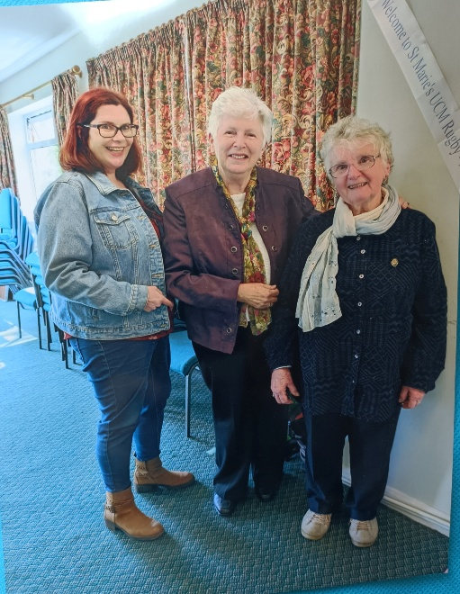
NEW MEMBERS

Birmingham
It's so hard to attract new members lately.
St Marie's in Rugby are pleased to have enrolled 3 new members, something to be celebrated.
L-r Caroline Cowen, Anne Taylor, Linda Hartley
Miriam Cunliffe Diocesan Media Officer

Leeds
We are hosting a Study Day/Get Together at St Benedict's Garforth on Saturday 20th September 2025. Louise George from Hallam is giving us a presentation " Pilgrims of Hope". There is Mass at St Benedict's at 10am to which you are warmly invited. We envisage coffee at 11 am then Louise will give the presentation followed by us having our packed lunches together. We hope it will be a lovely get together. No need to "book” just come along. I can send postcodes etc nearer the day.
Also, our Rosary Rally at the Cathedral is Saturday October 4th - details later.
Sue Oldroyd Leeds Diocesan Secretary
STEPPING OUT TOGETHER FOR CAFOD'S BIG LENT WALK 2025
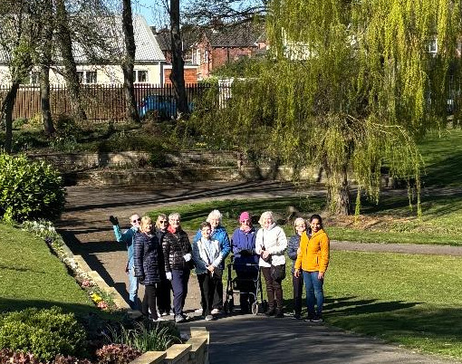
In this Jubilee Year, St Joseph’s UCM (Castleford) once again decided to step out to raise funds for CAFOD’S Big Lent Walk Appeal. Meeting after morning mass every Tuesday during Lent, members were blessed with bright sunshine for a gentle walk around the nearby Valley Gardens and afterwards shared a chat and a welcome cuppa in the Church Hall. Our thanks to Father John for his beautiful masses and encouragement, to parishioners who walked with us and to our generous sponsors who helped us to raise three hundred pounds for CAFOD.
Carol Sidebottom Secretary St Joseph’s UCM Castleford

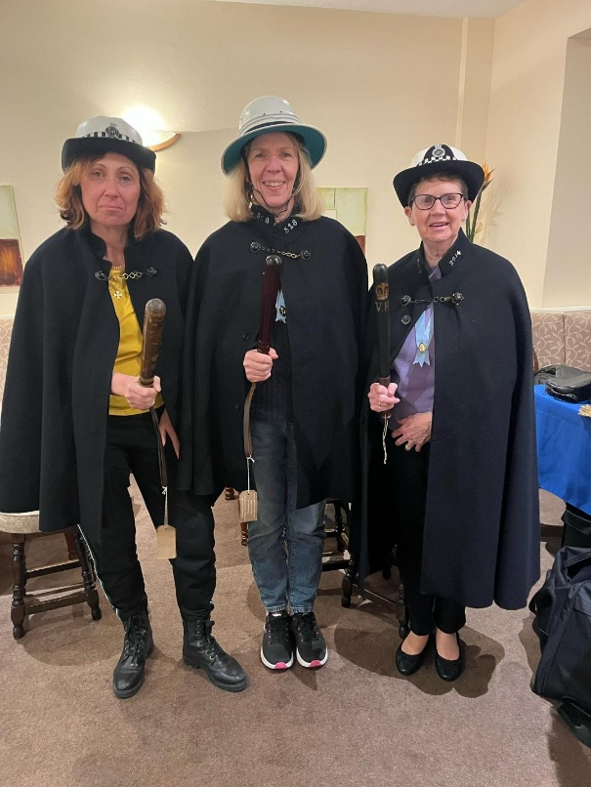
ON THE BEAT.
St. Benedict’s Garforth UCM enjoyed a most amusing and entertaining talk given by David Hardcastle, a retired police officer who volunteers at the Police Museum in Bradford.
He brought with him various exhibits which were passed around during the talk, and he used these exhibits to illustrate the history of policing in the UK.
The 1800 Police Act enabled 3 constables to use a Methodist church (on a night) to lock up law breakers in a cupboard.
In 1829 the London Met was formed after which Police officers had to swear as oath to the King
Carol Payne St. Benedict’s Garforth

Middlesbrough
Duke Of Edinburgh Awards.
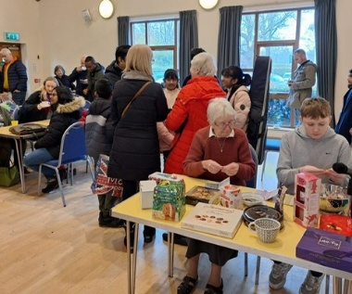
St. Aelred’s Foundation has been supporting a young parishioner George with the Volunteer Section of his Duke of Edinburgh awards. The programme was founded by the late Duke of Edinburgh in the 1950’s. George who is an active member of St. Aelred’s Parish has seen how hard people work to keep the community thriving. He approached Fr. Bill Serplus who was very willing to offer his support. He has been doing weekly jobs in the Repository, checking and updating stock, cleaning and is available to help parishioners with their purchases. George helps at the UCM coffee mornings, developing skills, confidence and knowledge of what is required to organise events. Not having realised an event as a coffee morning has so much planning going into it. At first, he asked many questions but now he uses his own initiative to tackle jobs independently. Along the way he has made many new friends, and may this continue when he completes the other sections of his Bronze award. Having indicated that he would like to progress with the Silver award and hoping that the parishioners and the UCM would help again in the future. I am sure that they will be delighted to continue to support him. The UCM wish him every success in the future and in all the other aspects which he must attain to reach the levels required for this prestigious award.
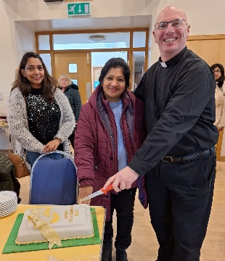
St. Aelred’s Feast Day
To celebrate St. Aelred’s Feast Day a parishioner Sulanka Fernando had prepared a beautiful cake for the occasion. As it was the UCM coffee am following the 9.30am Mass we were delighted that Fr. Bill could help Sulanka to cut the delicious chocolate cake and everyone present able to enjoy it.
Kath Stubbs Middlesbrough
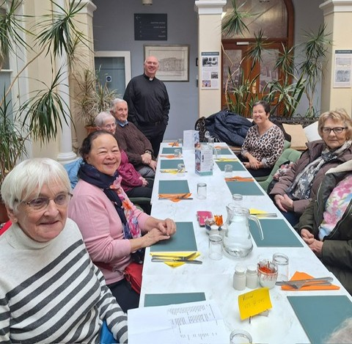
Bar Convent
St. Aelred’s Foundation visited the Bar Convent in York, the oldest convent in England. The convent is visited by people who can appreciate the Neo–Classical Georgian Chapel. We had Mass celebrated by our Spiritual director Fr. Bill Serplus. Following Mass we enjoyed lunch in the Café Atrium. Many of our members related memories of their school days as several had been pupils at the Bar Convent. In 1985 York schools became comprehensives, and after 299yrs the Nuns gave up their control of the school; it then became All Saints Catholic School. The convent now houses a wonderful museum, a cafe and an award-winning guest house. Only recently a unique illuminated medieval scroll revealing new insights into everyday life of over 500 years ago has gone on display. This scroll is known as an Arma Christi, featuring the prayer O Vernicle. Until now, only ten copies were known to have survived. As one of the few Catholic religious orders founded in England after the reformation, precious objects and documents were given to the Bar Convent sisters, who are now known as the Congregation of Jesus, for their safe keeping.
Northampton
St Joseph’s, St Neot’s newest member!
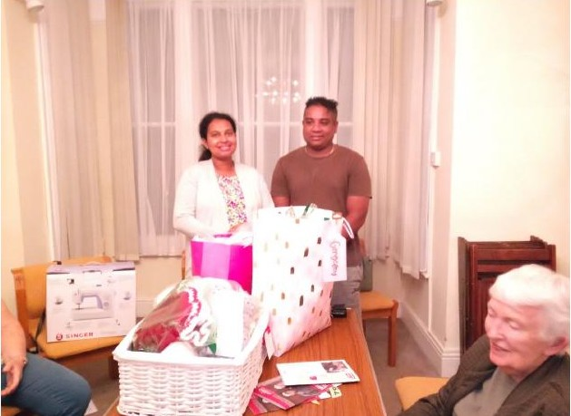
A beautiful baby girl born in October.
Her parents are from Sri Lanka and Nilmini’s mum was able to get a visa to come to visit for 6 months; they came along to our January meeting so that we could all see the new baby.
We had a baby shower at our September 2024 meeting – picture attached.
Ann Emblem

Portsmouth
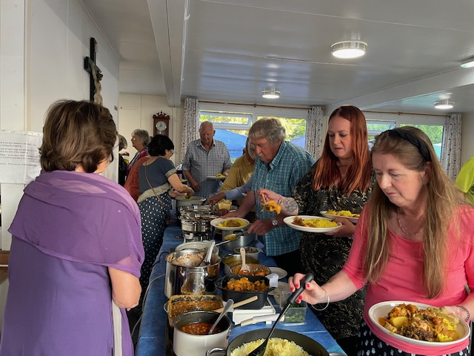
Sacred Heart Hook has a thriving UCM group with regular monthly meetings and lunch afterwards
There is a knitting and crocheting group that meet 2nd, 3rd and 4th Tuesday of the month
So far this year we have raised £320.50 for CAFOD from stations of the cross and a soup lunch every Friday during Lent.
A cake and plant sale which raised £400 for a school in Sri Lanka
Our latest venture was a well-attended curry night raising £961 for St Michael’s Hospice
We are in the process of buying and installing a defibrillator at Sacred Heart church - available for use by the local community. We are all looking forward to our next event
Helen Weston
Salford
Today we held an Easter Crafts afternoon in our church hall at St. Hilda's Tottington.
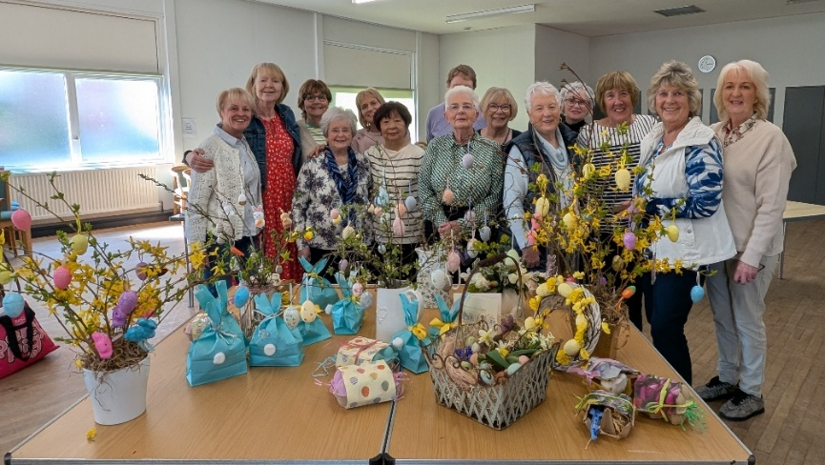
Easter bunny bags, Easter trees, Easter wreaths, and egg box parcels.
Thanks to Kate for leading the session.
We will all be taking part in Stations of the Cross on Good Friday, reading Mary's Way of the Cross by Richard Furey.
We find through Mary's eyes we feel the words personally being mothers ourselves.

Kim Fletcher UCM Foundation President

Shrewsbury
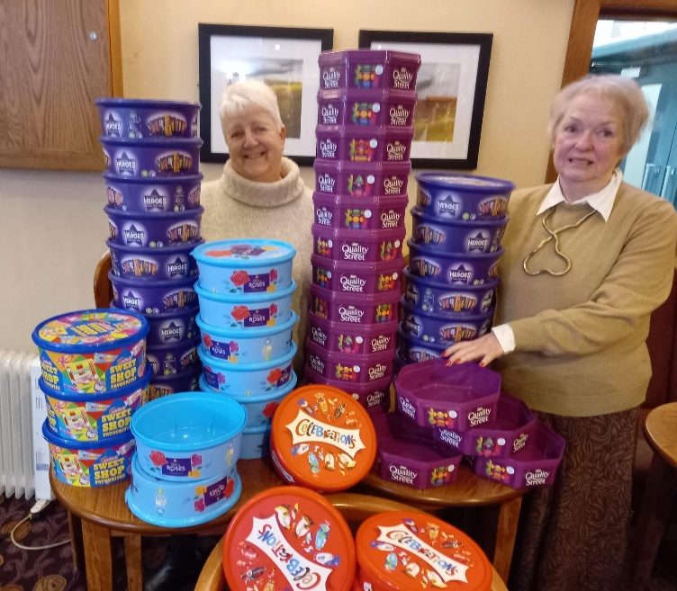
St Anne’s Foundation
62 plastic chocolate tubs were collected by members of St. Anne’s foundation Rock Ferry pictured here with the tubs are members Sue Butterworth and Yvonne Brady who delivered the tubs to the local Green King Pub, the tubs are recycled and monies raised donated to Macmillan Cancer charity. Last year the amount raised totalled £12.600 but it is hoped to surpass that amount this year. Well done ladies for what would seem such an enjoyable fundraiser to take part in.
Jean Clarke Acting Media Officer Shrewsbury

Southwark
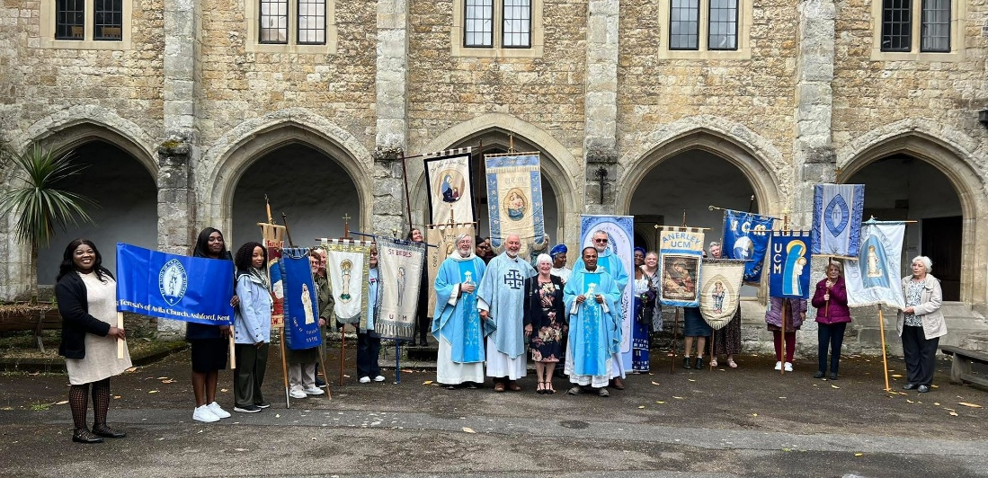
Annual Pilgrimage to Aylesford Priory May 24th 2025
On Saturday 24th May the Southwark Diocese held their Annual Pilgrimage to Aylesford Priory. It was a warm day but there was a chance of rain, so it was decided to hold our mass in the beautiful St Simon Stock Chapel. The service was led by our Spiritual Adviser Reverend Father Doug Bull. We were welcomed by our new Southwark President Majella Turner. The bidding prayers were written and read by members from Clapham Park, Sheppey and Sutton Foundations. Members from Ashford, Bostal Park and Deptford Foundations did the Offertory Procession.
Following lunch, we held the Rosary Procession around the Rosary Walk Garden carrying our Foundation banners and meditating on the Joyful Mysteries of the Rosary singing a verse of Our God Loves Me after each Mystery. Father Doug then led us with Benediction of the Holy Sacrament.
The day ended with delicious, shared cakes and refreshments and a good catch up with friends old and new.
The pilgrimage was a great success attended by over 150 members who all enjoyed a moving, spiritual day of reflection organised by our wonderful Southwark committee.
Joanne Pavitt
Westminster
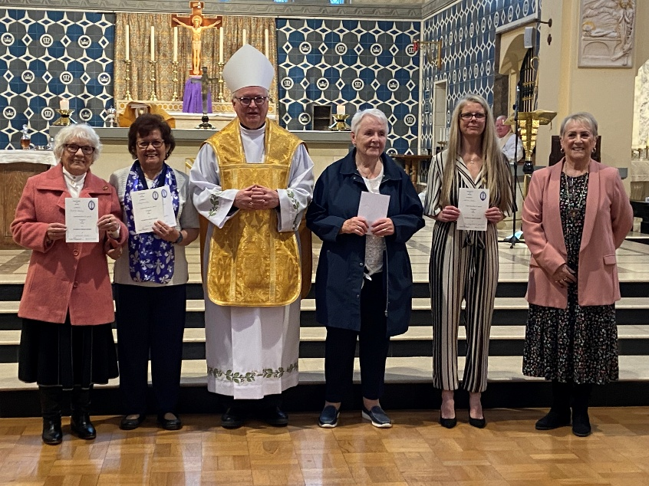
On Saturday 22nd March 2025 we held our Annual Diocesan Mass. The Celebrant was Bishop Jim Curry. Bishop Jim Curry gave out certificates to long term UCM members and thanked them for their work within the UCM. We celebrated afterwards in the Church Hall of Our Lady of the Rosary Church
From left to right Maria Dominy (30 years Hounslow), Peggy De Silva (Hounslow receiving certificates on behalf of Angela and Ruby Vaz, 20 years), Karen Meere (20 years, St John’s Wood), Pauline Shields (60 years West Drayton).
Elizabeth Bottomley Media Officer Westminster Archdiocese
St John’s Wood Foundation
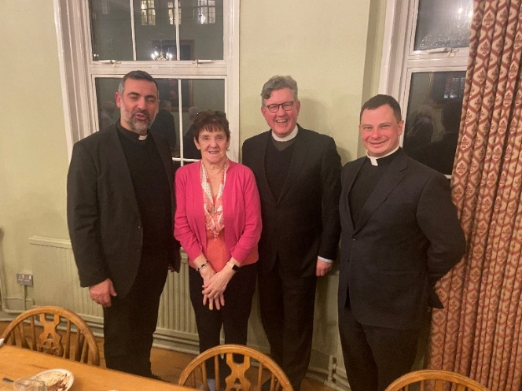
On the 5th February 2025 Sister Brigid, St John’s Wood Foundation, was a guest at the Allen Hall Seminary, Chelsea. Sister Brigid was invited by the Rector Canon John OLeary. Sister Brigid was invited because Rosemary Parsons, Westminster UCM Diocesan President has chosen the Seminary as her Charity over the 3 years. Unfortunately, Rosemary Parsons was unable attend. Photo: l to r, Fr Antonio Ritaccio, Pastoral Fomator, Sister Brigid St John’s Wood UCM Foundation, Fr Richard and Deacon Scott. Deacon Scott is being Ordained next year. A lovely meal was had by all.
++++++++++++++++++++++++++++++++++++++++++++++++++++++++++++++++++++++++++
ETERNAL REST GRANT UNTO THEM O LORD
Mrs. Brenda Gannon Independent member of Hallam Diocese
Lilian Van Spall Sutton UCM Foundation Southwark
+++++++++++++++++++++++++++++++++++++++++++++++++++++++++++++++++++++

Dates for your diary:
Autumn Council St. Chad’s Birmingham Saturday 11th October
National Council & AGM The Hayes Swanwick Monday 18th to Wednesday 20th May 2026

